CASE LABEL DOCUMENTATION

ADVANTZWARE DATA

The menu O-U-10 dumps data into a text file that the label software reads to print a case label.
N-K-1 BarDir character value lists the bar code software used which dictates the text file format that is down loaded. Most clients set this to SSLabel which is short for Sharp Shooter Label Matrix.

N-K-1 BarDir Description Field: Stores the folder / directory for storing the text file that is used with the label matrix or bar code anything software including finished goods load tags, work in process tags and raw material tags are stored as text files under the directory (folder) as defined by the description. There must be a folder (directory) on the machine that stores the Label Matrix software, labels and text file for Advantzware data. Single user licenses are normally loaded on the disk drive C:\BA\LABEL. Labels are created from the machine that label matrix is loaded on.

Advantzware creates a text file and dumps this into a folder. The text file is determined based on the N-K-1 CasTag integer value. If the value is 0, then the text file is pulled from the control parameter N-K-1 BarDir via the disk drive directory defined on the description field. Most clients name this BA \ LABEL. The label matrix forms most often also reside in this directory.

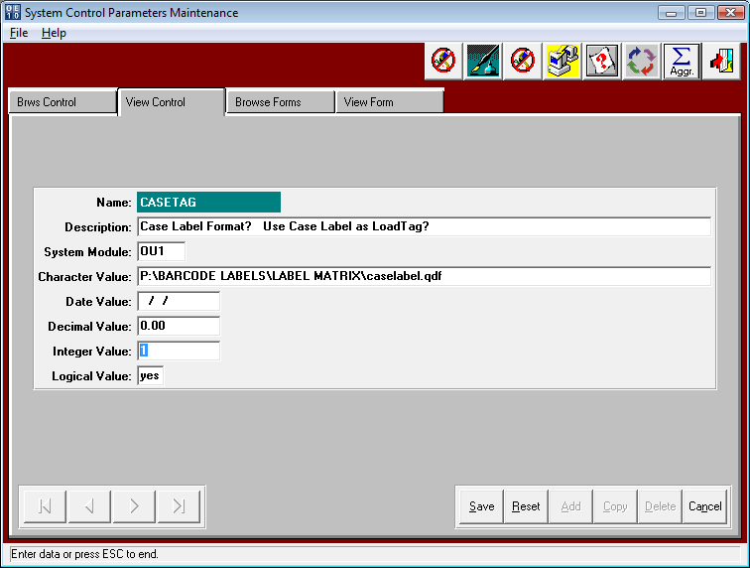

CASE LABEL DOCUMENTATION

ADVANTZWARE DATA for MULTI USER LICENSE

Label Matrix also has a server based product which would allow all users to point to one copy of this label generation software and share labels. Sharp Shooter computer users such as forklift mounted computers or handheld devices may connect to the server via terminal services communications. Under this scenario, all the users will not want to share the same text file.
The V10 users file under menu N-U has a field called Pallet Load Tag / Case Label Text File Path. Each user must define a unique text file location that has been created on the network server. Once updated, the user will create labels specific to their orders without unwanted merging with other users.

Advantzware creates a text file and passes it to a text file. The text file is determined based on the N-K-1 CaseTag integer value. When the value is 1, then the text file is pulled from the user file, therefore the Advantzware data will be transferred to the users text file when printing a case label. If the user file is blank, then the logic work as if the integer value is 0 as explained above.

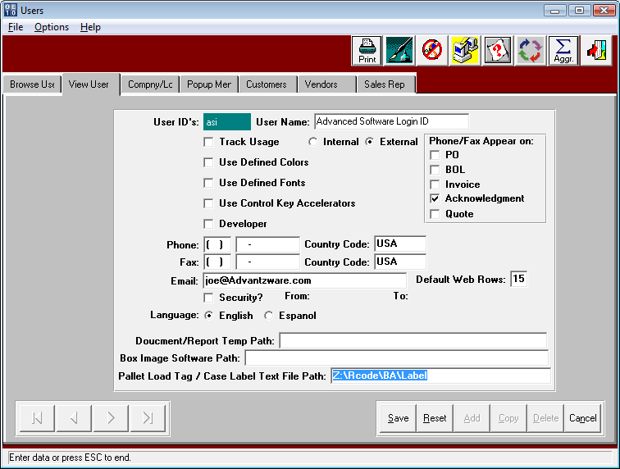

CASE LABELS (O-U-10)

STORING SPECIFIC LOAD TAGS TO PRINT

The control parameters N-K-1 CasTag and N-K-1 CasLabel dictate all the unique printing logic for printing case labels via the menu options O-U-10.
N-K-1 CasLabel Logical Value = YES will turn on logic to print CASE LABELS per item. Customer shipto or Customer. Case Labels to be printed will transfer to the O-U-10 field based on the following hierarchy.

A) Finished Goods Item File - Total/CP# Folder
B) N-K-1 CaseLabel View Form by Shipto when A is blank
C) N-K-1 CaseLabel View Form by Customer when A & B are Blank
D) N-K-1 CaseLabel View Tab, Character Field when A, B and C are Blank

The finished goods item file can store a specific pallet tag by item under the Totals/CP# tab.
An F1 on this field provides a search of the disk drives to find the proper label.
Below, I have defined the Z:\BARCODE LABELS\LABEL MATRIX\loadtag.qdf

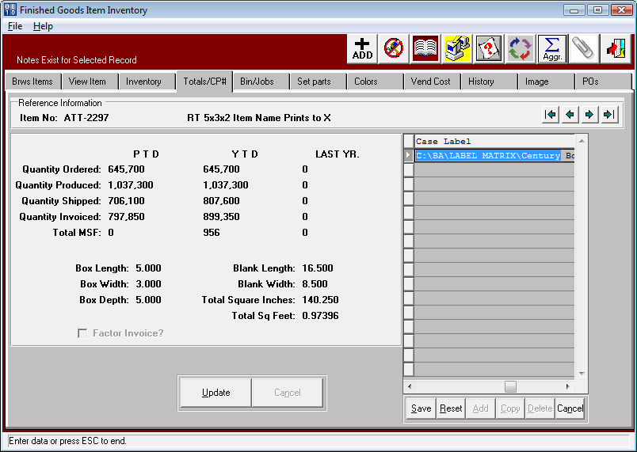

When Printing the Case Label, once an order # is entered, the program will display the item.
This will also display the CASE LABEL based on the hierarchy noted above. If a unique case label exists for an items customer part number, this label will display. If the item does not have a unique case label, then the label by customer’s ship to location will print. Next, the program will search for a unique label by the customer. Finally, if there are no unique labels defined, the program will search the CaseLabel character value. If all are blank, the program allows the end user to pick a label from the Bar Code Software Program. Please note, any label that displays on the O-U-10 print screen may be changed before printing. A new toggle box called AUTOPRINT will automatically launch Label Matrix and print the selected file with the printing the Label.
CASE LABELS (O-U-10)

The control parameters N-K-1 CasTag and N-K-1 CasLabel dictate all the unique printing logic for printing case labels via the menu options O-U-10. N-K-1 CasLabel Logical Value = YES will turn on logic to print CASE LABELS per item. Customer shipto or Customer. Case Labels to be printed will transfer to the O-U-10 field based on the following hierarchy.

A) Finished Goods Item File - Total/CP# Folder
B) N-K-1 CaseLabel View Form by Shipto when A is blank
C) N-K-1 CaseLabel View Form by Customer when A & B are Blank
D) N-K-1 CaseLabel View Tab, Character Field when A, B and C are Blank

If the label is blank in the Totals/CP# tab for the finished goods item, then the system looks for a unique tag by Customer Ship To location or by Customer as defined in the View Forms tab.

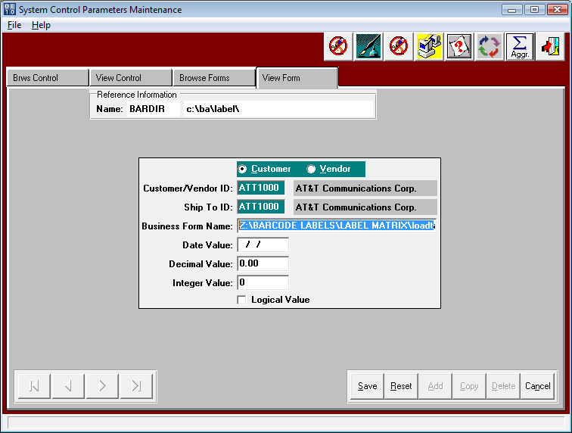

When Printing the Case Label, once an order # is entered, the program will display the item.
This will also display the CASE LABEL based on the hierarchy noted above. If a unique case label exists for an items customer part number, this label will display. If the item does not have a unique case label, then the label by customer’s ship to location will print. Next, the program will search for a unique label by the customer. Finally, if there are no unique labels defined, the program will search the CaseLabel character value. If all are blank, the program allows the end user to pick a label from the Bar Code Software Program. Please note, any label that displays on the O-U-10 print screen may be changed before printing. A new toggle box called AUTOPRINT will automatically launch Label Matrix and print the selected file with the printing the Load Tag.
printing. A new toggle box called AUTOPRINT will automatically launch Label Matrix and print the selected file with the printing the Label.
CASE LABELS (O-U-10)

The control parameters N-K-1 CasTag and N-K-1 CasLabel dictate all the unique printing logic for printing case labels via the menu options O-U-10. N-K-1 CasLabel Logical Value = YES will turn on logic to print CASE LABELS per item. Customer shipto or Customer. Case Labels to be printed will transfer to the O-U-10 field based on the following hierarchy.

A) Finished Goods Item File - Total/CP# Folder
B) N-K-1 CaseLabel View Form by Shipto when A is blank
C) N-K-1 CaseLabel View Form by Customer when A & B are Blank
D) N-K-1 CaseLabel View Tab, Character Field when A, B and C are Blank

If options A, B and C are above are blank then the program will search for a unique pallet tag for the customer code only. As you can see below, only the customer code is defined.
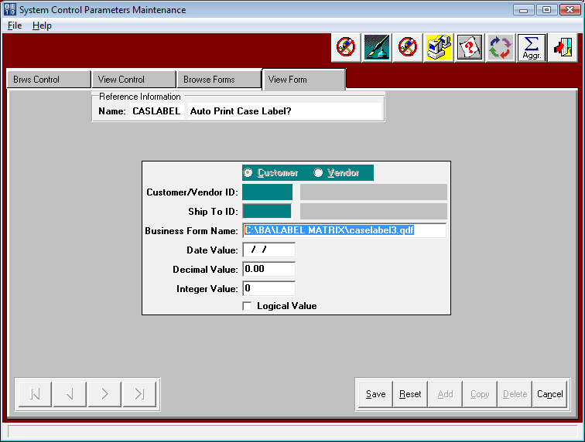

When Printing the Case Label, once an order # is entered, the program will display the item.
This will also display the CASE LABEL based on the hierarchy noted above. If a unique case label exists for an items customer part number, this label will display. If the item does not have a unique case label, then the label by customer’s ship to location will print. Next, the program will search for a unique label by the customer. Finally, if there are no unique labels defined, the program will search the CaseLabel character value. If all are blank, the program allows the end user to pick a label from the Bar Code Software Program. Please note, any label that displays on the O-U-10 print screen may be changed before printing. A new toggle box called AUTOPRINT will automatically launch Label Matrix and print the selected file with the printing the Load Tag.
printing. A new toggle box called AUTOPRINT will automatically launch Label Matrix and print the selected file with the printing the Label.

CASE LABELS (O-U-10)

The case label creation screen provides many options to select what fields are downloaded to the text file. The number of duplicate labels to print via the integer value defined on the N-K-1 CasLabel parameter. Then total number of case labels to print for a specific order quantity is dictated by the N-K CasLabel Decimal Value. Decimal Value = 0 will generate just 1 unique case labels. This option would be used when producing case labels for each pallet produced on the production floor. Decimal Value = ? will default the number of case labels to 0 so that the number of tags to be created must be manually entered. Decimal Value = 1 will to generate the total case labels required by dividing the order quantity by the case count. This option is used when printing in the office before actual production.

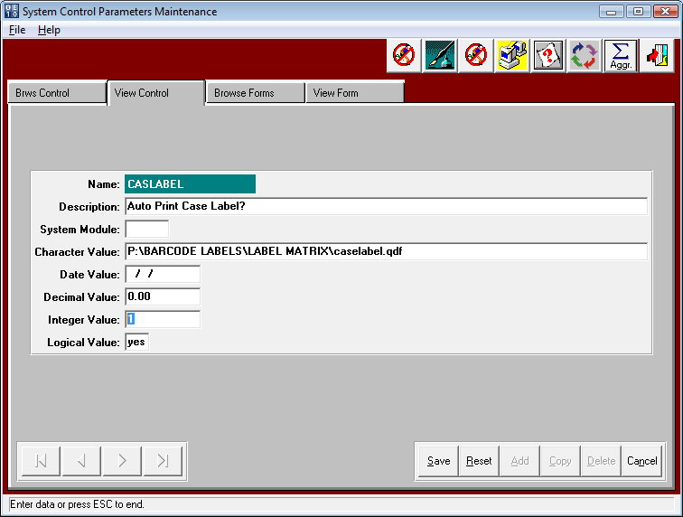.

Printing CASE LABELS (O-U-10)

The case label creation screen provides many options to select what fields are downloaded.
The user can include the unit/case count and cases per pallet. The user can also include the
Overrun quantity and which customer purchase order number to print. If they select the purchase order on the release folder, they will need to select a date range. The specific case label that will print will transfer to this screen so that the user can confirm the correct label or change the label.
To print the same label again and again, click the FREEZE Label choice. You will also notice the location of the text file that the Advantzware data will be stored prior to printing.

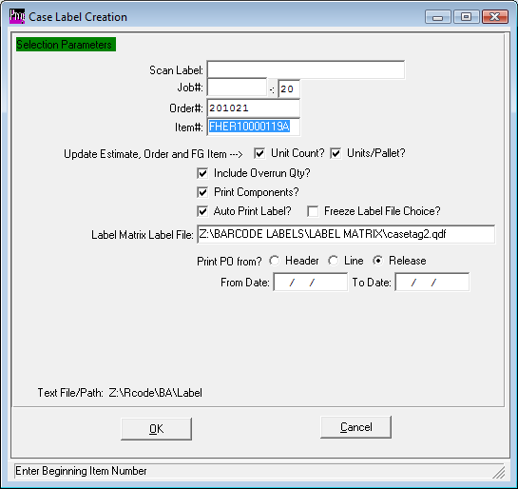

Printing CASE LABELS (O-U-10)

Once you click the “OK button to create the case label, the following worksheet confirms the exact item, order quantity, case count, cases per pallet and other information. Other temporary fields may be added to the worksheet such as color, lot#, weight and other fields that customers may need added in the future. The DONE button will actually dump the data to the text file and simultaneously print the case label if the AUTOPRINT option is selected. Please note, the label matrix software also has the ability to prompt for temporary fields prior to printing the label.
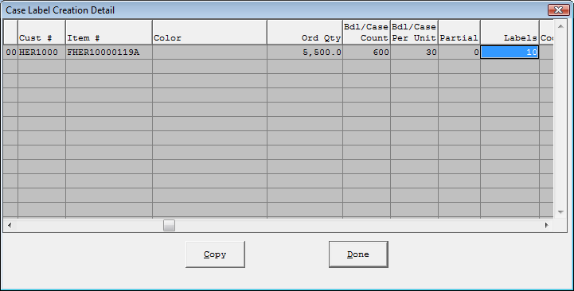

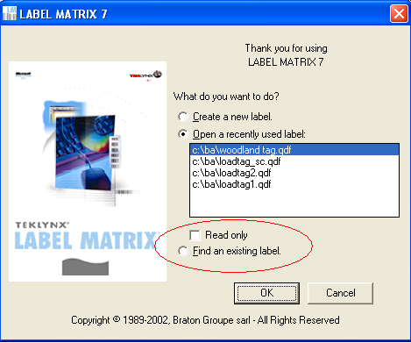

When you select a label format a sample of it is displayed. The “grid” icon on the top of the screen will allow you to display the file of load tag data that was created in Advantzware. You then can use the printer icon, (or the menu option File/ Print) to print the tags.
You can also modify tags and save a custom one to use for your plant.
